Niño a Niño Instructions
Contents:
- Introduction to the Niño a Niño program
- Project Steps for Raising Money

- Project Steps for School Supplies Drives
- Teacher Testimonial for Raising Money
- What Students Gain

HOW YOU can become a MEMBER OF
MANO A MANO!
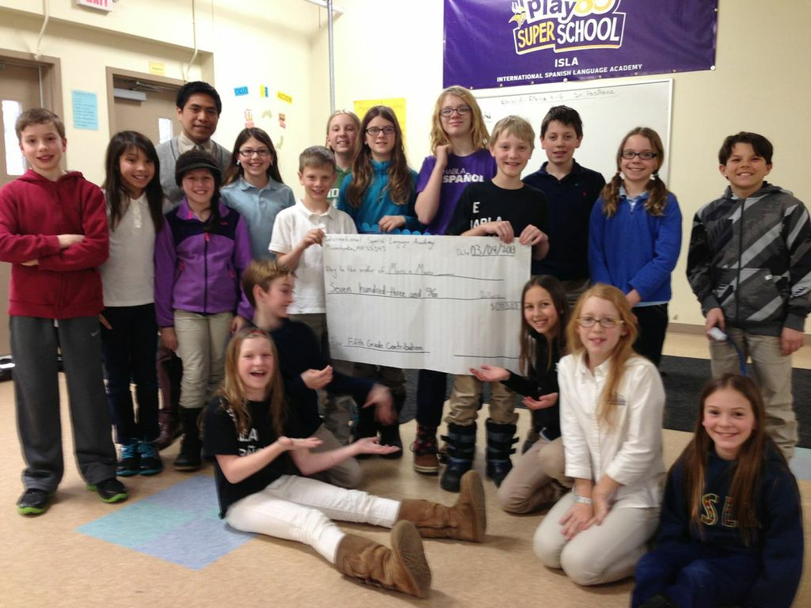
- Introduction to the Niño a Niño Program

Niño a Niño means Child to Child in Spanish

What is the Niño a Niño Program?
Niño a Niño is a program began by students in Minnesota to support education in rural Bolivia through the St. Paul based international nonprofit called Mano a Mano International.

What do Students do to support the program?
Students do a wide variety of activities like raising money through whatever means works best for them such as penny wars or a bake sale. Some students collect school supplies or books in Spanish. All efforts go to promote Mano a Mano International’s education programs which include the construction of schools in rural areas (so far 48 schools have been built!), training seminars for rural teachers, and providing materials to students and classrooms throughout rural Bolivia.

- Project Steps for Raising Money:

FIRST: Decide on a Fundraising Strategy that would work best for your school:

- Penny Wars – in a penny warm two or more classes compete to win a fundraising competition. Each class has a bucket for collecting coins. The value of any pennies collected by a group count positively toward that group’s point total, while the value of other coins or dollar bills are subtracted. When one class is winning, the other classes can add silver coins and dollar bills to decrease their amount earned. Class to raise the highest value wins!
- Change Collection Competition – students collect and deposit change and small bills into jars. Class who raises the most money wins!
- Bake Sale or Garage Sale
- Be Creative with your own Fundraising Ideas! Mano a Mano will support you anyway we can!

SECOND: Get Ready and Go!

- Principal Approval: Inform principal of the project and reassure that this project requires no time from the principal.
- Inform the Staff: Take 5 minutes during a staff meeting to introduce the project – Mano a Mano can come and give a presentation if appropriate
- Inform the school: Make a PA announcement or announce the project at an assembly to inform the student body
- Inform Parents/Guardians: Send the Niño a Niño Parent letter through a newsletter or send home with students
- Prepare Activity: For penny wars or change collection, decorate jars and set up documentation systems to track funds raised and display somewhere students can watch the progress
- Designate Responsible Student Group to track progress daily
- Have fun and reward the winning or participating classes with a prize!
- Have students stay connected to the Niño a Niño Facebook page so they can see how their funds are used in rural Bolivia!

- Project Steps for School Supplies Drives:

- Begin again by informing school principle, administration, students, and their parents.
- Set out boxes to collect supplies – usually done at the end of a school term
- Set out sign above or on boxes to inform participants of what it is that Mano a Mano accepts as donations:

- Notebooks cleared of pages with writing
- Folders
- Markers
- Pens
- Pencils
- Erasers
- Scissors
- Pencil Sharpeners
- Colored Pencils
- Crayons
- Glue Sticks/Bottles
- Books in Spanish

- Transport supplies to the Mano a Mano warehouse in St. Paul!
Mano a Mano International
925 Pierce Butler Route
St. Paul, MN 55104
Call Office Mananger, Dana, to let her know you are coming with supplies: (651) 457-3141

- Teacher Testimonial for Raising Money
From Liz Hathaway Castelán at Highland Park Middle School – St. Paul:

“This project was so fun! My 8th grade advisory took it on (with no convincing necessary on my part) and they want to do it again next year in their new schools!

Here is how it happened:

Joey, a student in my Global Studies class, told me about Mano a Mano International and his desire to do something in our school. I told him I wanted to help and we figured out a time to meet after school with his mom. He had written a letter to the principal so I knew she was aware and supportive of the idea.
We talked for a bit and brainstormed ideas. Another school’s idea of having a change collections competition sounded easy enough and we decided to give it a try, even though it was late in the school year and a lot was going on. We came up with a plan and I emailed the principal for approval, which she quickly granted.
- Joey would present the project of Mano a Mano to the staff at our upcoming monthly staff meeting, promising to take no more than 5 minutes of the meeting time, including the short (3 minute) film from Mano a Mano. The staff was quite moved and seemed enthusiastic, some requesting access to the film to show their advisories even though we would be showing it to everyone later.
- At the end of that week, Joey and some friends presented the idea to the whole school via our all-school TV announcements including the (thre) minute Mano a Mano video. The top advisories were promised donut parties as a reward.
- Meanwhile, students in my advisory were decorating peanut butter jars for each advisory in the school. They signed up to be the runner(s) to the different Advisories in our school. A poster was created to mark the collections from each Advisory with the names and room numbers listed vertically, and marks that went horizontally for every $5 or so. Then we came up with the idea to draw the outline of a school and add bricks for every $10 – with a goal of 10 rows of ten $10 bricks. We put that in the school atrium and a sign with the actual number of dollars collected as well.
- I arranged for a PR blast to go out to all staff, parents and community. I sent periodic reminders to staff to let them know how things were going. The change collections competition lasted two weeks. Every morning students from my Advisory visited the other advisories and collected the money, counting and charting the amount each day. We collected over $1250! It was amazing! The kids had a great time doing it and felt pretty accomplished; they can’t wait to do it again!”

- What Students Gain:

- Perspective to better understand poverty and its relevance to individuals around the world.
- Understanding of the challenges faced by rural communities in their daily lives and what international organizations are doing to help
- Experience in how to, as a team of dedicated students, make a difference locally and impact global communities
- Consideration for the differences and similarities of children from the developing world; awareness of the culture of rural life when faced with extreme poverty
- Appreciation for the beautiful culture of Bolivia and the resources and opportunities they have as students in the United States
